**UNIVERSITY OF ENGINEERING AND TECHNOLOGY, LAHORE**

**(NAROWAL CAMPUS)**

**­**

**NAME :**

**ABDULAHAD HUSSAIN**

**ROLL NO. :**

**549**

**SECTION:**

**A**

**SUBJECT:**

**PROGRAMING FUNDAMENTAL**

**LAB #11:**

**Task No. 01:**

**Statement :**

Write a program that input marks of 5 subjects of a student and calculate its average and grade in a function and array respectively

1. Calculate average by referance
2. Show grade by referance(A,B,C)

**Source Code:**

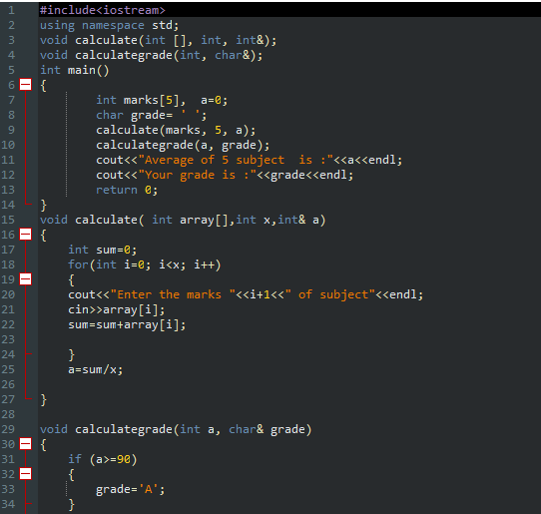

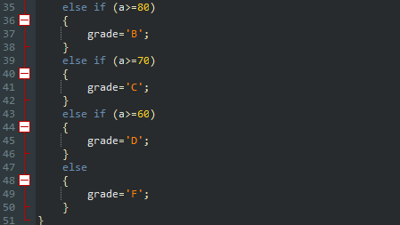

**Output:**

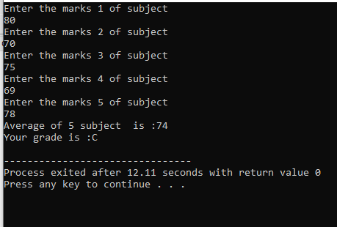

**Flow Chart:**

**Task No. 02:**

**Statement:**

Write a program that search the smallest element in a 2d array by column.

**Source Code:**

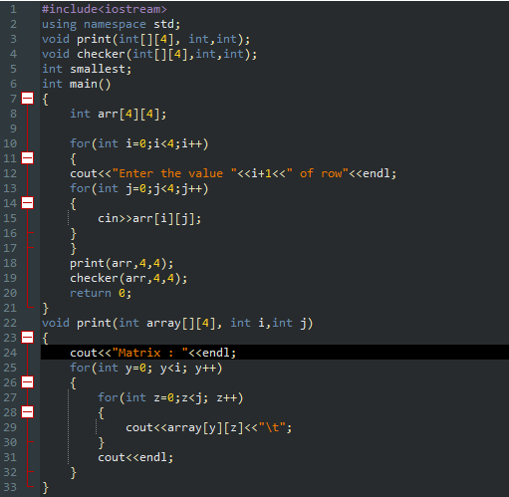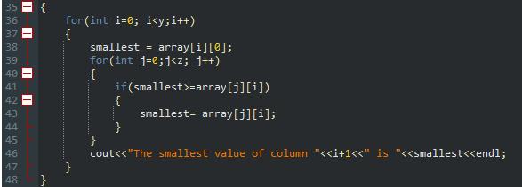

**Output:**

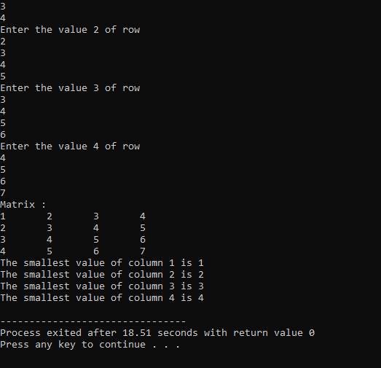

**Flow Chart:**